EXPERIMENT NO : 04

AIM : To understand continuous integration, install and configure Jenkins with Maven/Ant/Gradle to setup a build job

THEORY :

MAVEN

Maven is a build automation tool used primarily for Java projects. Maven can also be used to build and manage projects written in C#, Ruby, Scala and other languages. The Maven project is hosted by the Apache Software Foundation, where it was formerly part of the Jakarta project.

ANT

Apache Ant is a Java library and command-line tool whose mission is to drive processes described in build files as targets and extensions points dependent upon each other. The main known usage of Ant is the build of Java applications. Ant supplies a number of built-in tasks allowing to compile, assemble, test and run Java applications. Ant can also be used effectively to build non-Java applications, for instance C or C++ applications.

**STEPS FOR INSTALLING AND SETUP OF JENKINS:**

**Installing Steps:**

**Step 1:**

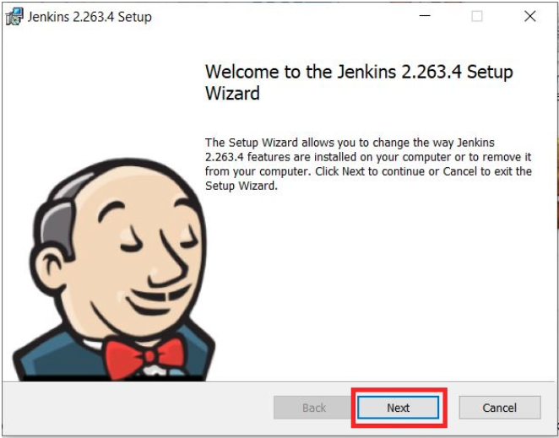

**Step 2:**

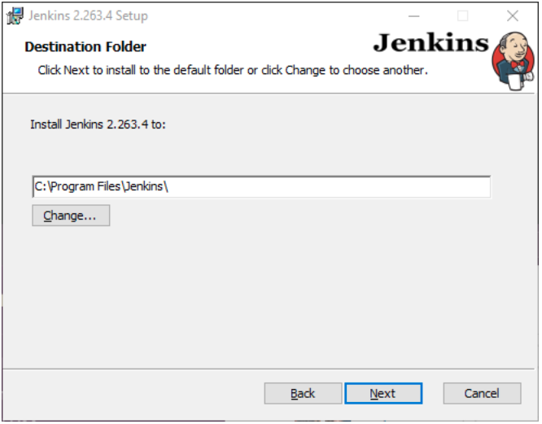

**Step 3:**

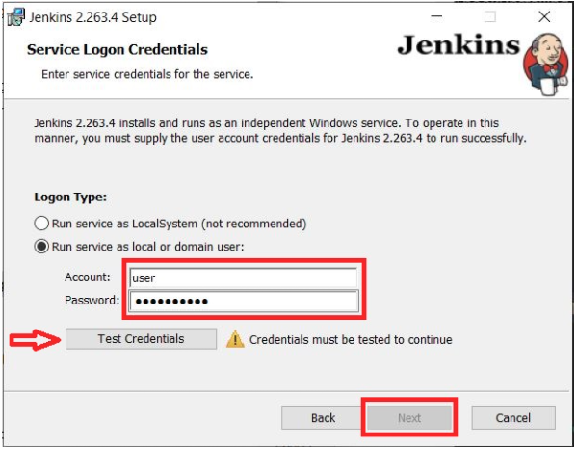

**Step 4:**

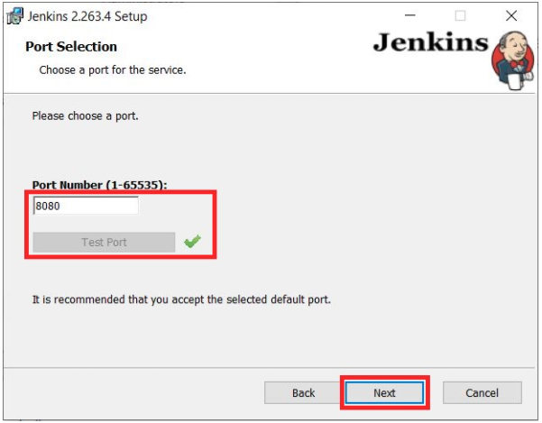

**Step 5:**

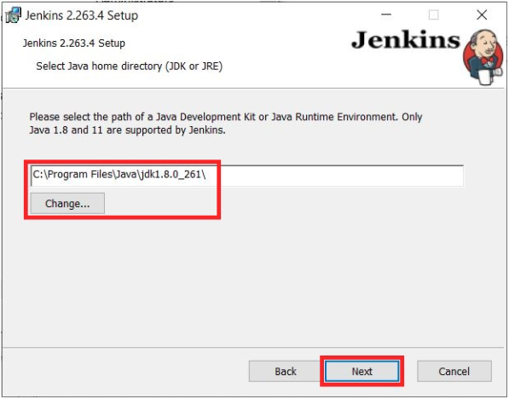

**Step 6:**

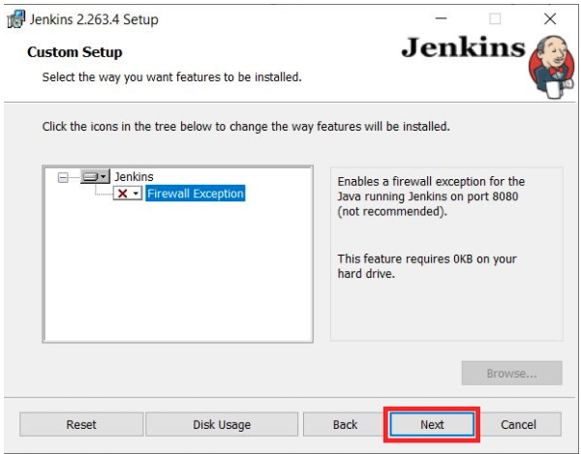

**Step 7:**

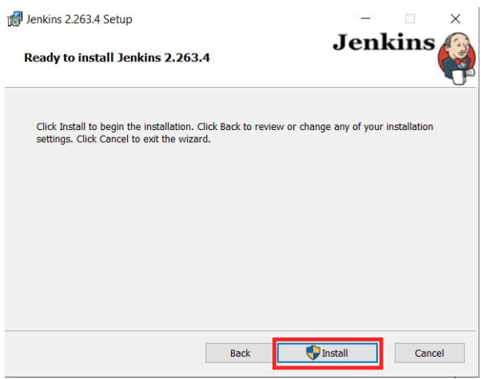

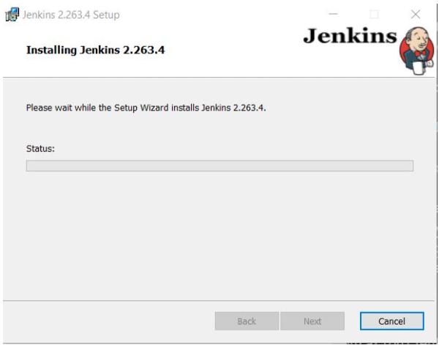

**UNLOCKING JENKINS**

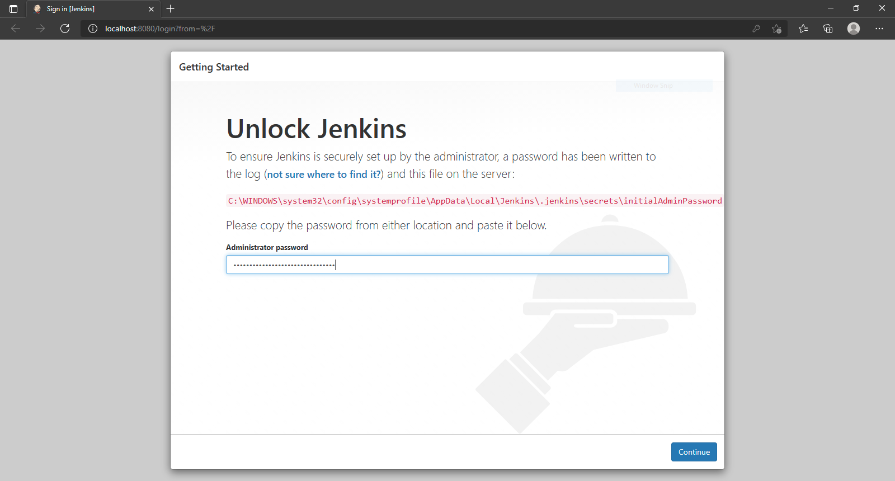

**CUSTOMIZE JENKINS WITH PLUGINS**

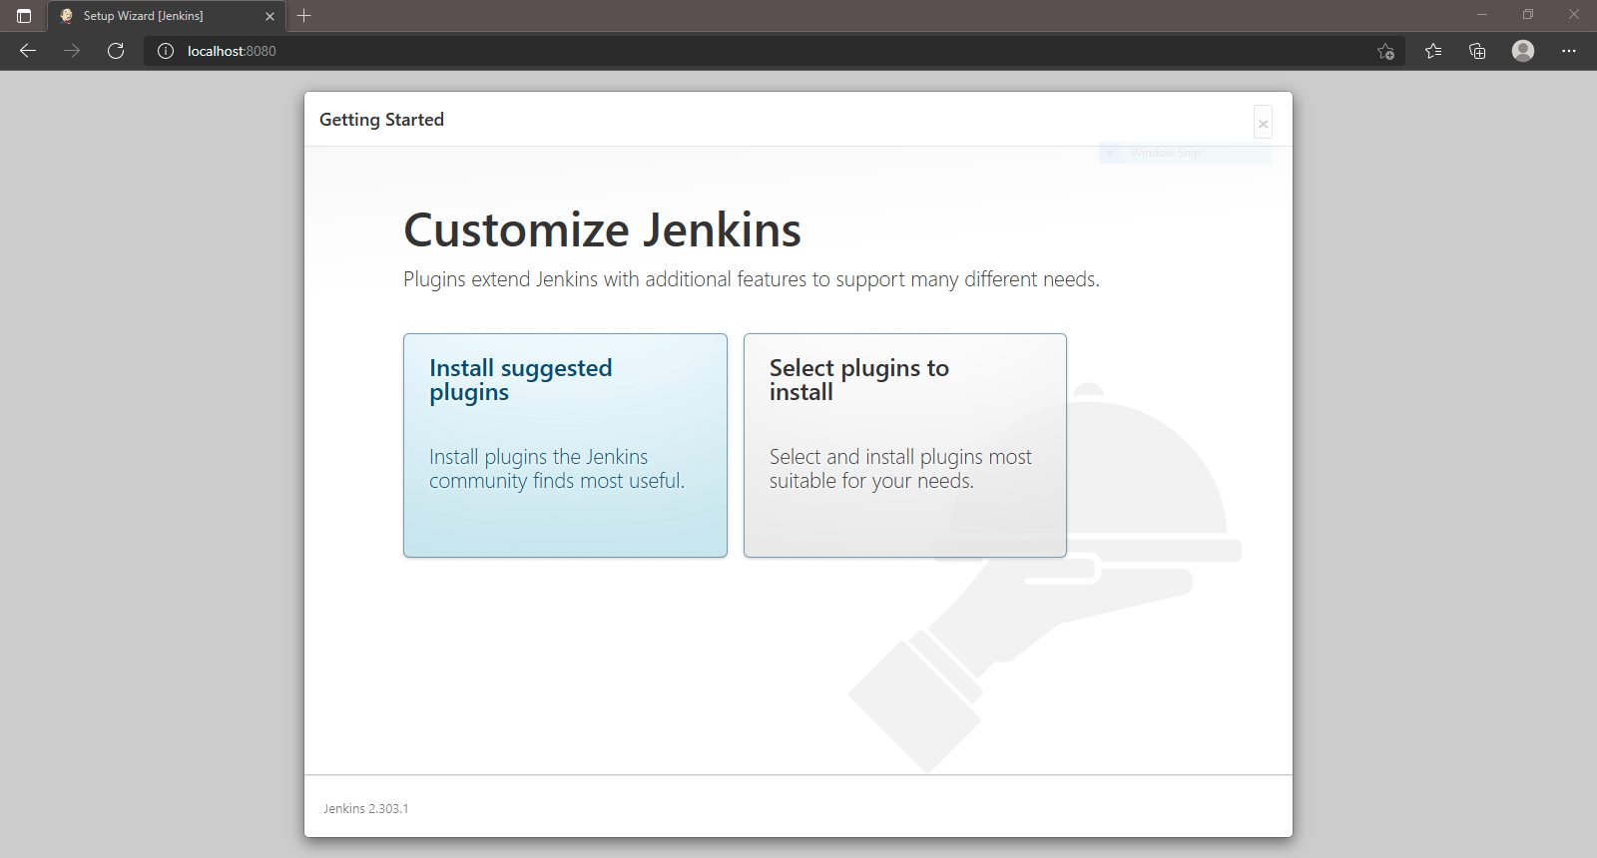

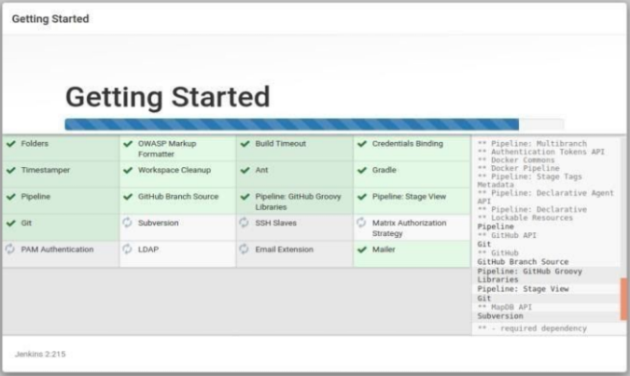

**USER LOGIN:**

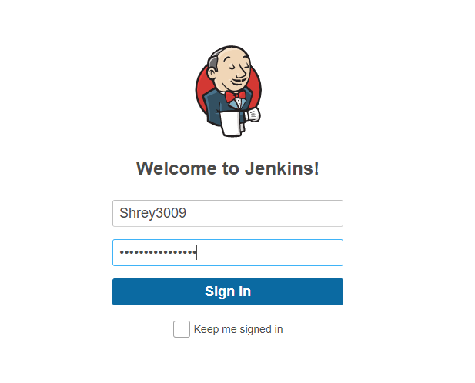

**MANAGE JENKINS:**

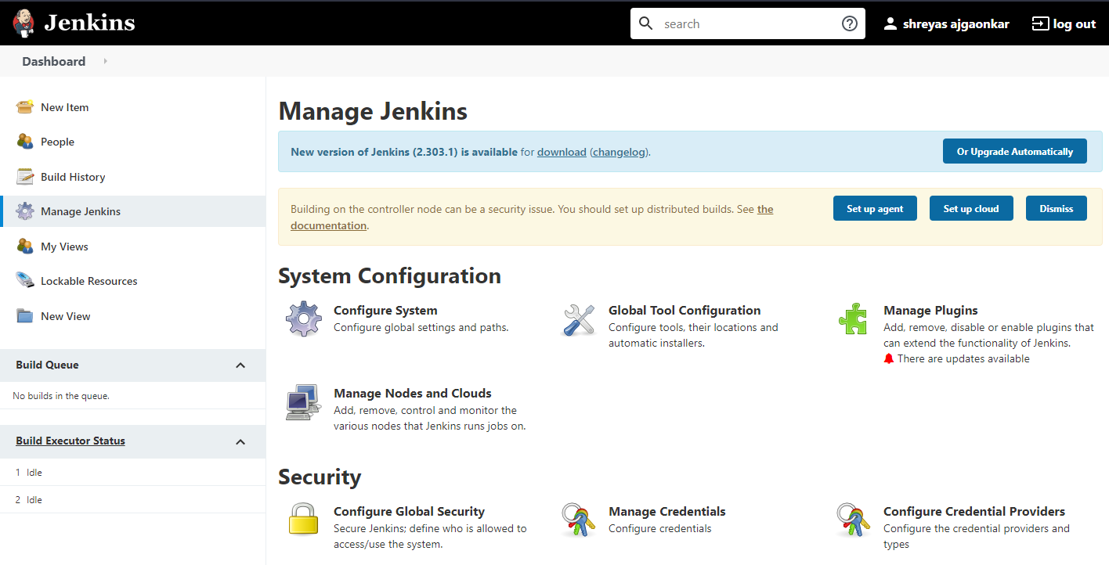

**ADD JDK:**

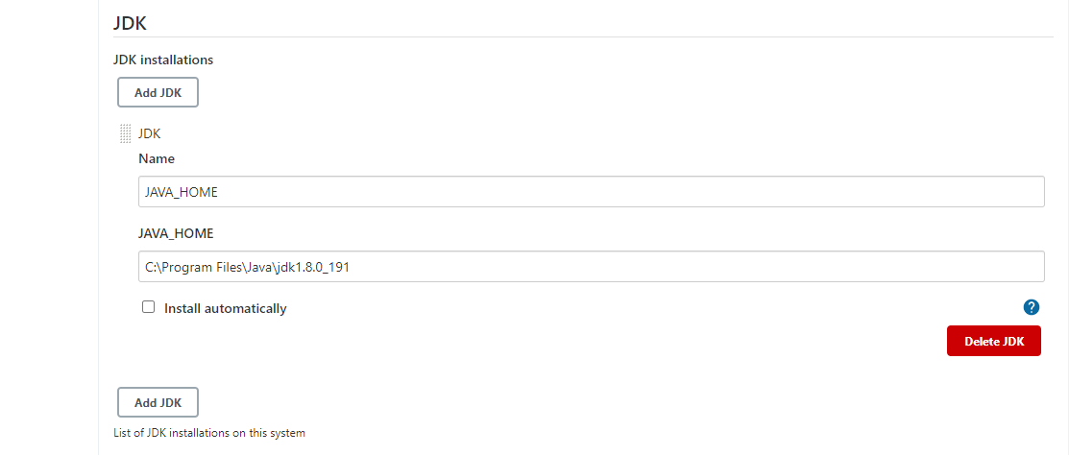

**ADD GIT:**

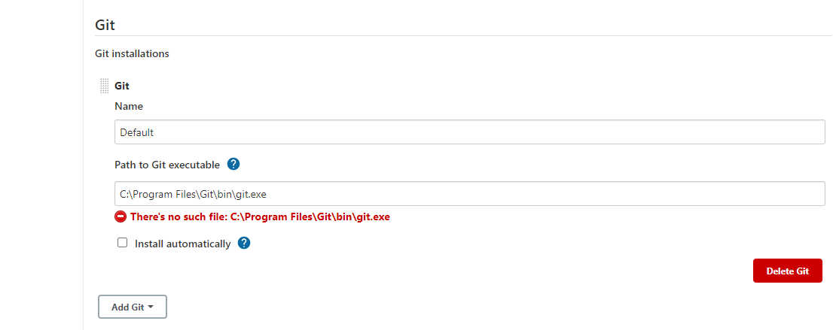

**ADD GRADLE:**

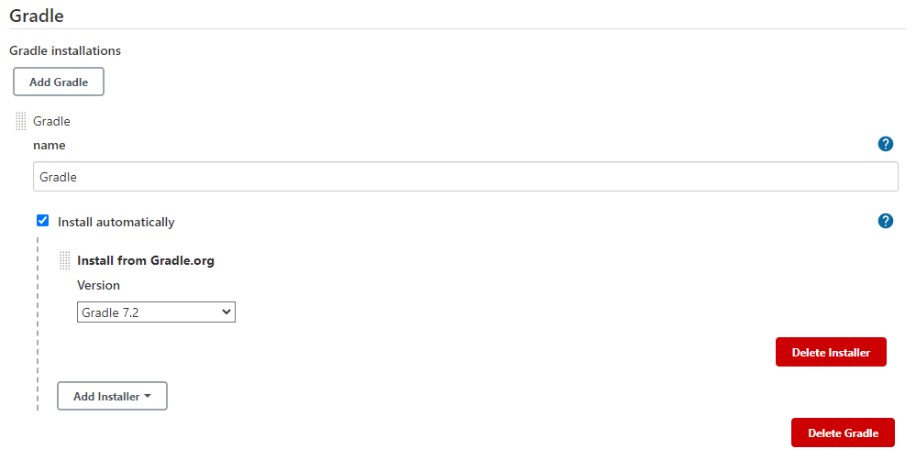

**ADD ANT:**

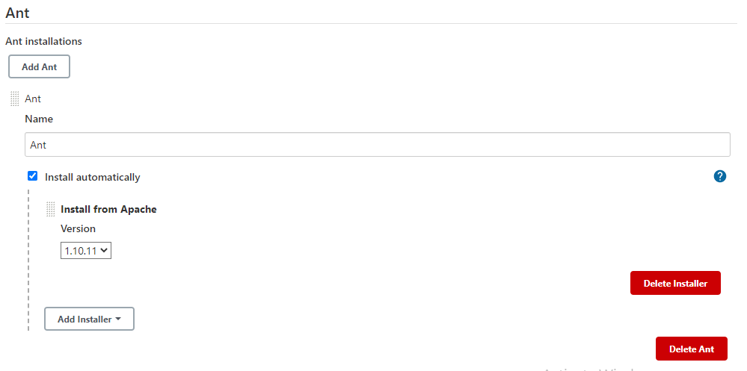

**ADD MAVEN:**

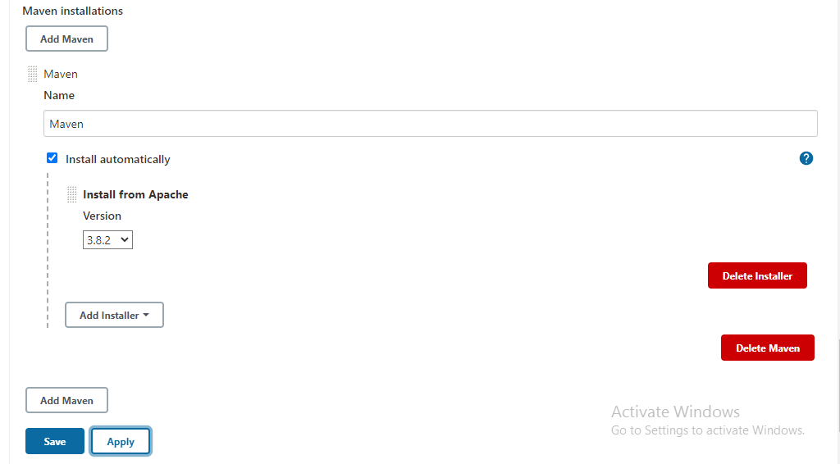

**A NEW BULID JOB IN JENKINS:**

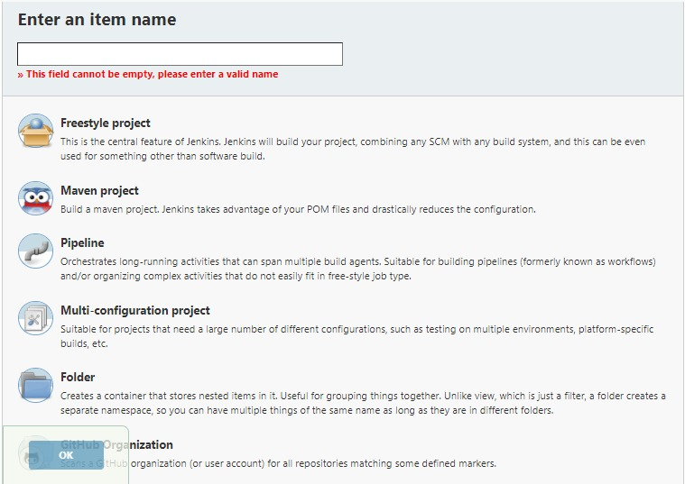

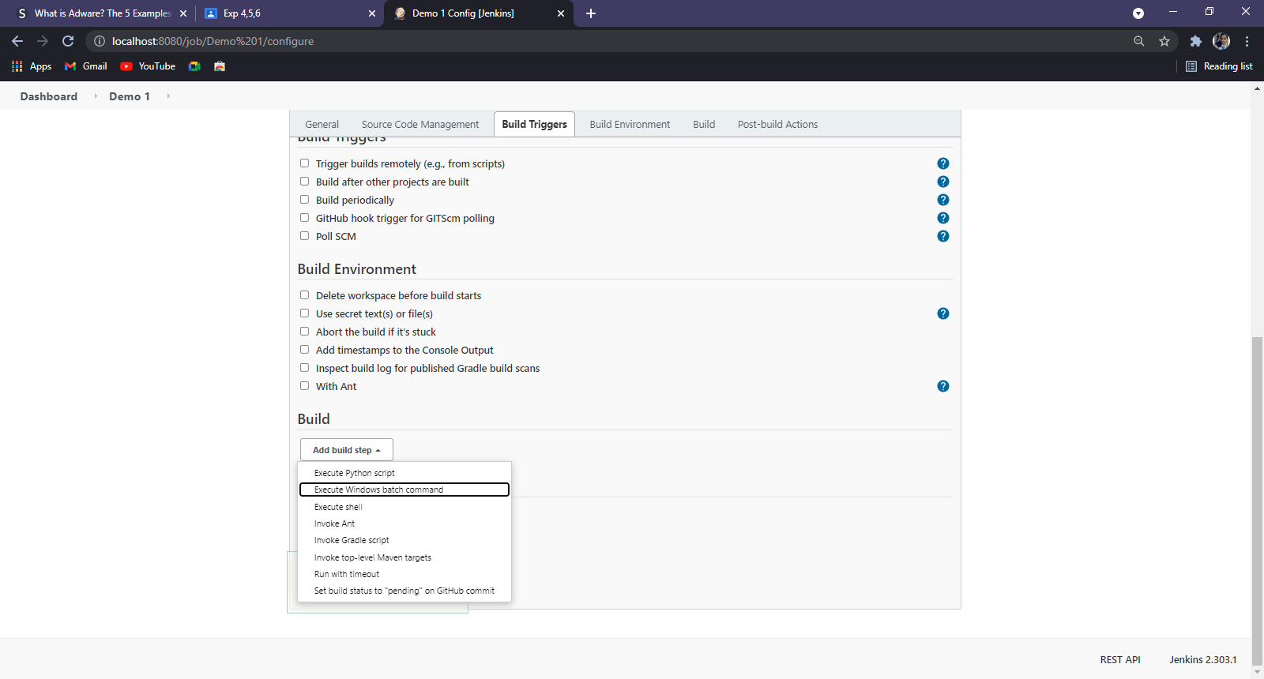

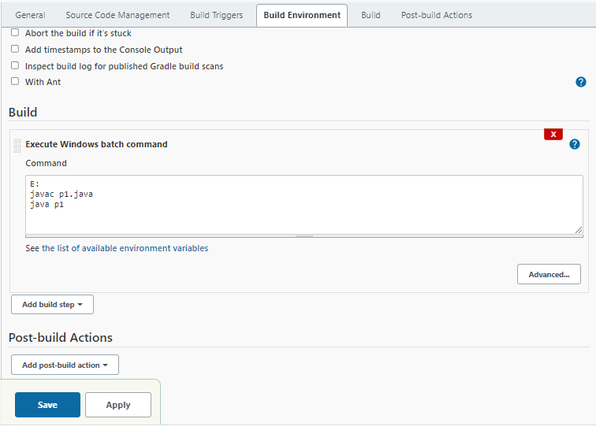

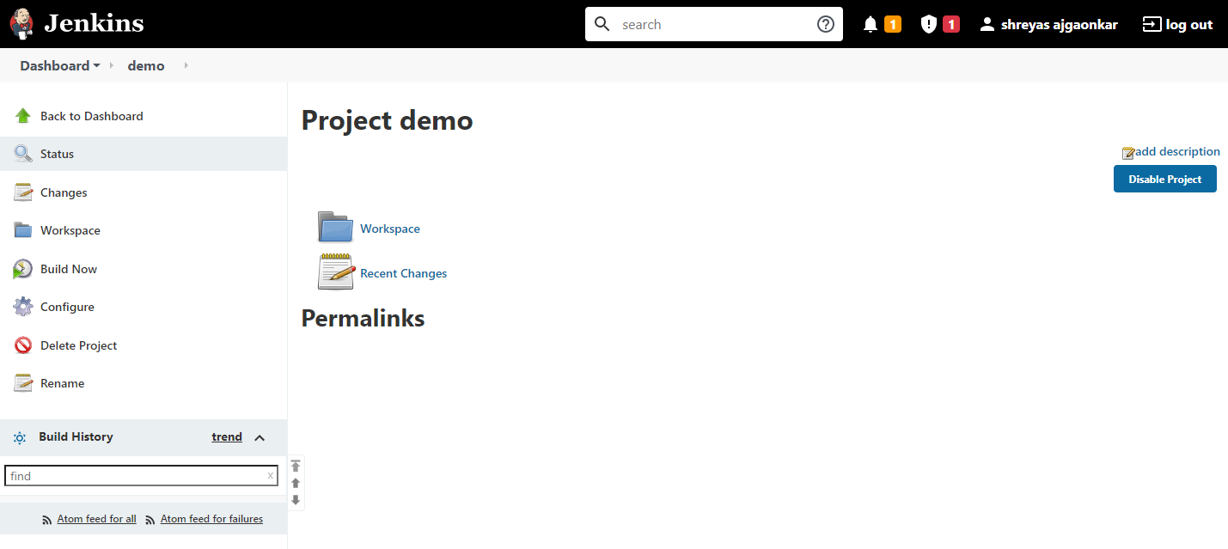

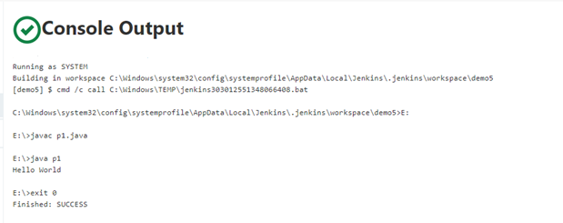

**CONCLUSION :** Hence, we understood Continuous Integration, install and configure Jenkins with Maven/Ant/Gradle to setup a build Job.